**Level Design Document for:**

*Zombie Platformer*

All work Copyright ©2021

Written by James Webster

Table of Contents

1.0 Revision History 4

2.0 level Design Overview 4

2.1 Level Design concept 4

2.2 Gameplay Mechanics 4

2.3 Camera 4

3.0 Theme and Characters 4

3.1 Characters 4

3.2 Theme 4

4.0 Level Information 5

4.1 Level Location 5

4.2 Level Setting 5

4.3 Level Layout/Architecture 5

5.0 Level Design 5

5.1 Main Objectives 5

5.2 Optional Objectives 5

5.3 WOW Moments 5

5.4 Level Progression 5

5.5 Player Experience 5

6.0 Art Style and Aesthetics 6

6.1 References 6

6.2 Lighting 6

6.3 SFX/Music 6

6.4 Particle FX 7

7.0 Level Asset List 7

8.0 Delivery Milestones 7

# 1.0 Revision History

<As you revise the document, list what was changed and when it was changed>

|  |  |
| --- | --- |
| Version | Description |
| 1.0 | Initial Template |

# 2.0 level Design Overview

## 2.1 Level Design concept

<A two or three sentence description of your level design based on your topographical maps and sketches>

## 2.2 Gameplay Mechanics

<Player and gameplay mechanics used in the level design including how your environment will support them>

## 2.3 Camera

<Simple key phrases for camera system used>

# 3.0 Theme and Characters

## 3.1 Characters

<Player’s character and any other characters in the story. This is a body of text and should be elaborated>

## 3.2 Theme

<This is a body of text and should be elaborated, environment, player universe, world values>

# 4.0 Level Information

## 4.1 Level Location

<This is a body of text and should be elaborated>

## 4.2 Level Setting

<This is a body of text and should be elaborated>

## 4.3 Level Layout/Architecture

<This is a body of text and should be elaborated, include your 2D topographical maps here>

# 5.0 Level Design

## 5.1 Main Objectives

<This is a body of text and should be elaborated, how do you progress? Open world? Interior? Sequential? Pick-a-path? Procedural?>

## 5.2 Optional Objectives

<What does the player try to accomplish on each level/mission?>

## 5.3 WOW Moments

<Side missions, free roam, secrets>

## 5.4 Level Progression

*<Difficulty cure, Progression Diagram or Beat Sheet>*

## 5.5 Player Experience

*<What is motivating the player? Emergent gameplay opportunities>*

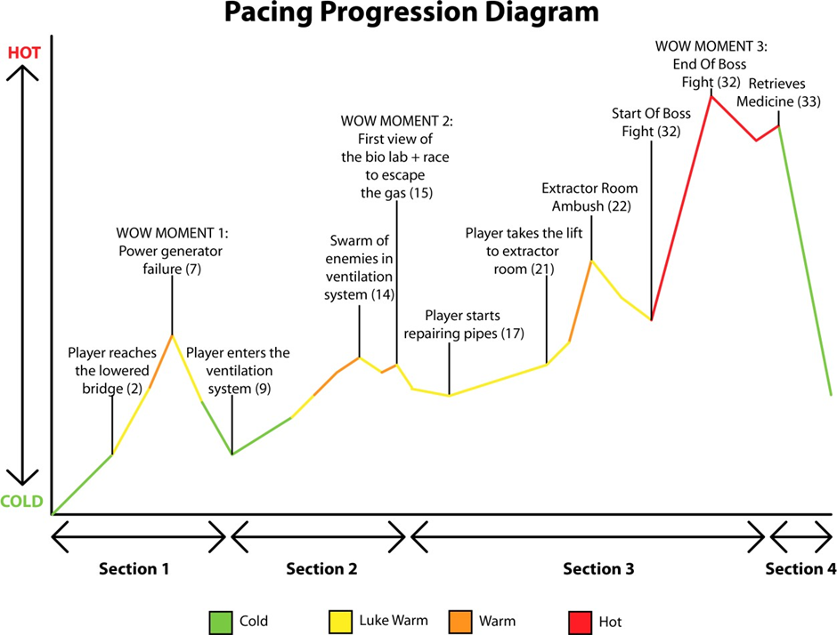

# 6.0 Art Style and Aesthetics

Refer to the Mood Boards and 2D level Design maps

## 6.1 References

<Provide images here or links to mood boards and reference images>

## 6.2 Lighting

<Color ,mood, Signposting, Narrative >

## 6.3 SFX/Music

List music clips and where they’re used.

List all sound effects and where they’re used

## 6.4 Particle FX

List particle effects and why they are used

# 7.0 Level Asset List

<Static and dynamic objects relative to the environment>

|  |  |
| --- | --- |
| Item | Description |
| Car | Modern sedan |
| Bus | Drivable |
| Bus Wreckage | Static, damaged by explosion, scalable |
| Ladder | Industrial, metal, painted yellow, 4m, 8m variants |
| Table x 3 | Office, Kitchen, warehouse |

# 8.0 Delivery Milestones

<Provide milestone dates for Prototype, Testing Phases and Final Build>

**Prototype:** When will your first playable prototype of your level be ready? This will be a prototype/grey-box that will show off how your level works.

**Testing and Iteration:** You will need to test your level, get feedback, and make changes to your level and design based on your testing results. Allocate time for this to be done and complete.

**Final Build:** The final polished and complete build of your game.